Abdullahi Tajudeen

Task 1
Swapping of storage device:
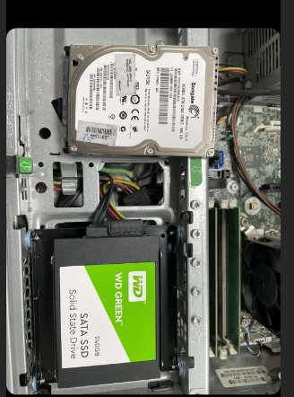
The hard drive was swapped to SSD. The old hard drive was removed from the motherboard and was replaced with new storage device of SSD. There was no problem when swapping the hard drive. The SSD worked well when it was tested.

Fitted a New RAM:
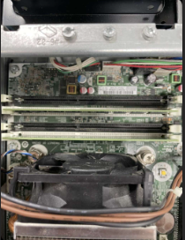
The RAM was upgraded to 8GB so I had to add another 4GB to the 4GB RAM that was there before. So that the PC can run the software program faster and smoothly. There was a little problem while fixing it because it wasn’t easy to fix it at first but it later went through and it worked perfectly.
Fitted a New Graphics Card:
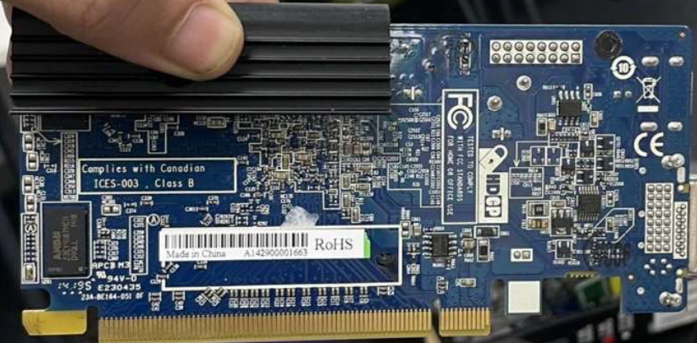
I located the PCI slot on the motherboard, and I slotted in the Graphics card which is also known as the GPU. I make sure the GPU is compatible with the computer so that there wont be any problem during installation. The Graphics card was installed So that the PC can have better graphics appearance for the graphics designer.
Replacing The Network Card with a PCI version:
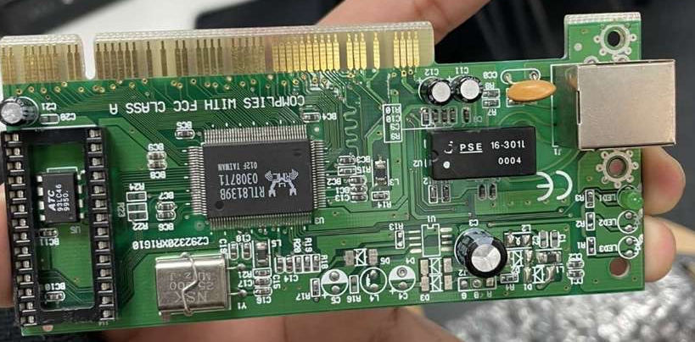
the network card was replaced with a PCI version. I located an available PCI slot on the motherboard, and I slotted in the new Network card. There was no error during the installation process.

